**AI Assisted Coding - Lab Test 1**

**Q2. Multi-Stage AI Prompting (5M)**

**Prompt :**

1. Write a Python program that prints the multiplication table of 5

**Code 1 :**

# Program to print the multiplication table of 5

number = 5

print(f"Multiplication Table of {number}:")

for i in range(1, 11):

result = number * i

print(f"{number} x {i} = {result}")

**Output 1 :**

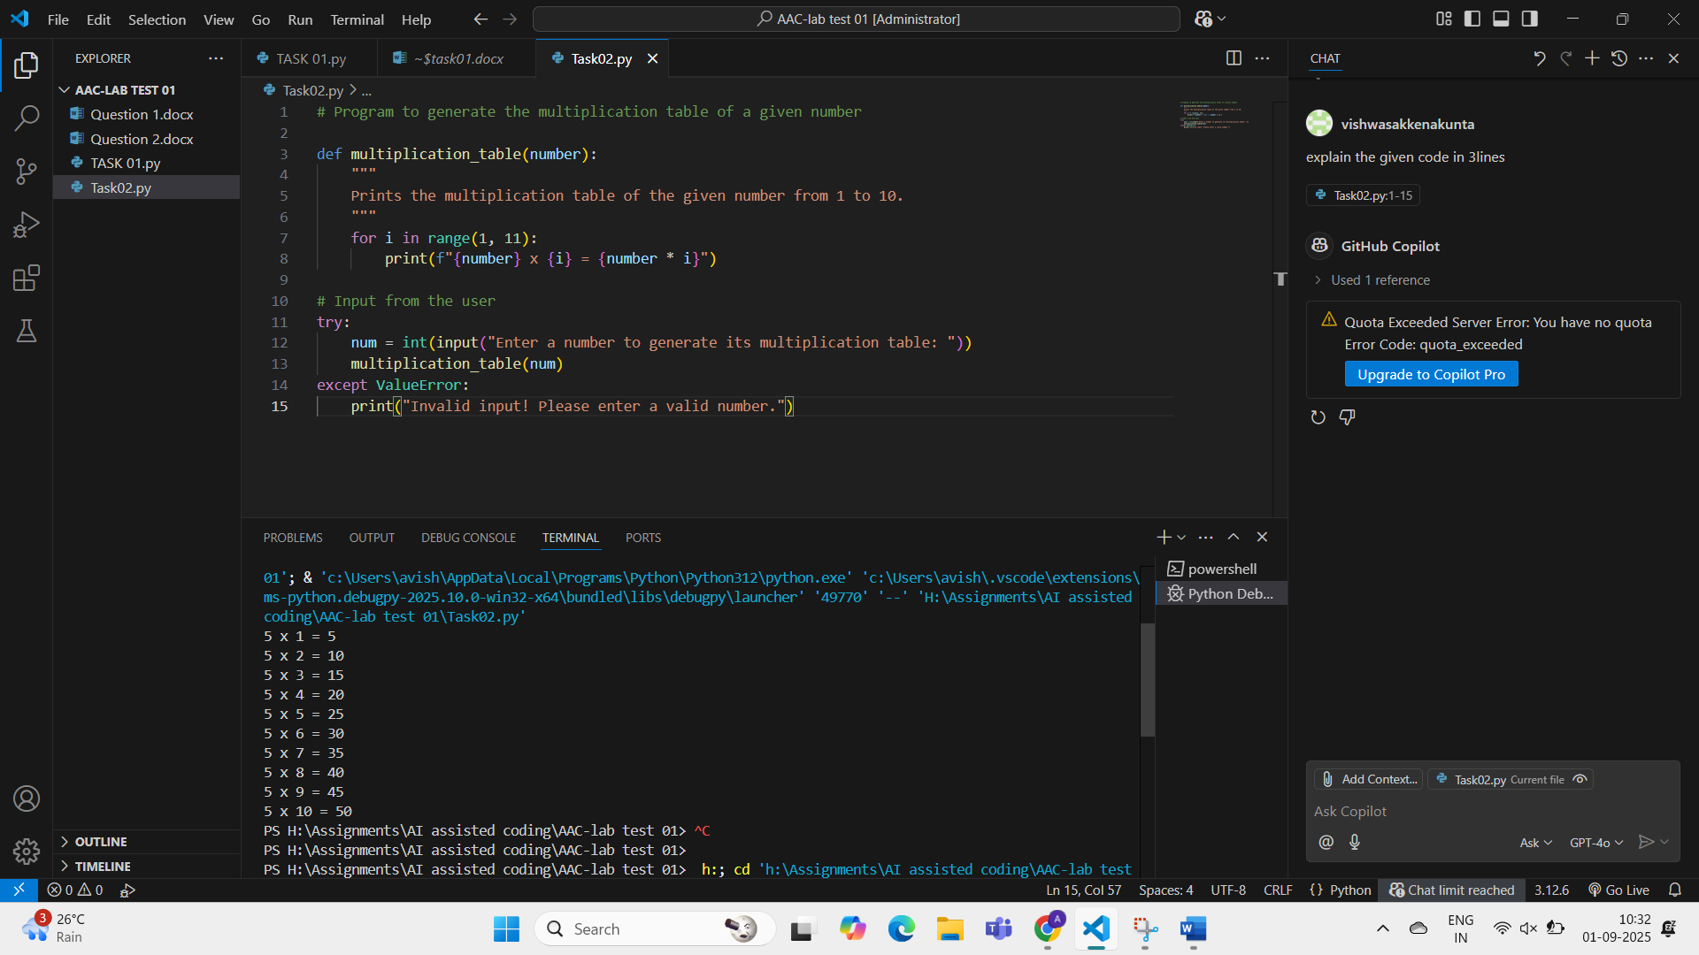

1. Take the previous prompt and ask the user to enter any number greater than 0 and give the multiplication table according to the input

**Code 2 :**

# Program to print the multiplication table of a user-input number

# Ask the user to enter a number greater than 0

# Program to generate the multiplication table of a given number

def multiplication_table(number):

    """

    Prints the multiplication table of the given number from 1 to 10.

    """

    for i in range(1, 11):

        print(f"{number} x {i} = {number * i}")

# Input from the user

try:

    num = int(input("Enter a number to generate its multiplication table: "))

    multiplication_table(num)

except ValueError:

    print("Invalid input! Please enter a valid number.")

**Output 2 :**

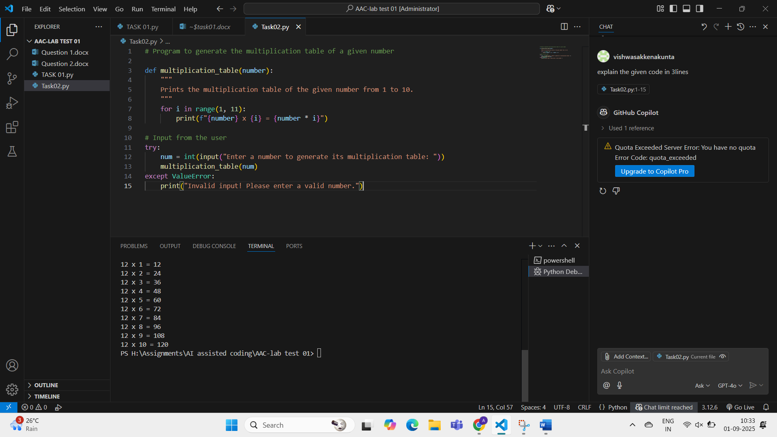

**Observation :**

This program ask the user for a number, Then uses a loop to multiply it by values from 1 to 10.

Each result is printed in the format “number x i =product”